Network Cable and connectors

Task 1 :- Draw a labeled diagram of a Cat6 Ethernet cable, showing the color order of wires in the T568B standard and labeling the RJ-45 connector pins.

ANS :-
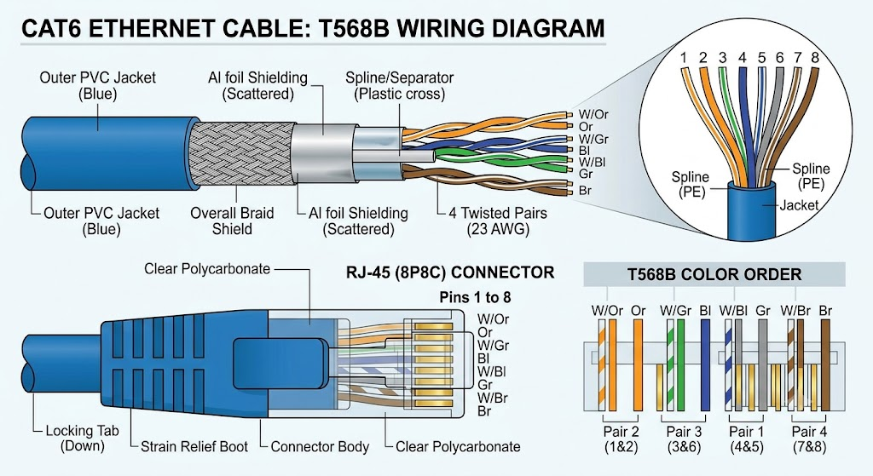

Task 2 :- List three types of network cables (such as Cat5e, Cat6, and fiber optic) and for each, mention one real-world app or device (like a WiFi router, Zomato POS terminal, or IPL streaming server) where it would be used, explaining why.

ANS :-

- Cat5e Cable :-

  - Where it’s used : A Zomato POS terminal in a restaurant.
  - Why :- POS terminals only send basic transaction data, so they don't need high speeds. Cat5e is cheap, flexible, and easily handles standard internet speeds up to 1 Gbps.

- Cat6 Cable :-

  - Where it’s used : A home Wi-Fi router.
  - Why :- Cat6 carries faster speeds (up to 10 Gbps over short distances) with less interference, making it ideal for streaming, gaming, and connecting busy home devices.

- Fiber Optic Cable :-

  - Where it’s used : An IPL streaming server in a data center.
  - Why :- Fiber uses light to transfer massive amounts of data at ultra-high speeds over long distances without lagging, which is necessary to stream live HD video to millions of viewers at once.

Task 3 :- Watch a YouTube video showing how to crimp an RJ-45 connector onto a network cable, then write down the step-by-step process in your own words and mention two common mistakes to avoid.

ANS :-
*Steps :-
1. Strip the Cable: Strip off about 1 inch (25 mm) of the outer plastic jacket using the stripper edge of your crimping tool.
2. Untwist & Straighten: Untwist the pairs of internal wires and straighten them out so they are easy to arrange.
3. Arrange the Wires: Place the colored wires in the correct standard sequence (e.g., T568B: White-Orange, Orange, White-Green, Blue, White-Blue, Green, White-Brown, Brown).
4. Trim the Wires: Flatten the ordered wires between your fingers and cut them evenly, leaving about half an inch (12 mm) exposed.
5. Insert into RJ-45 Plug: Hold the connector with the release clip facing down and slide the wires firmly into the plug until they reach the very end.
6. Crimp the Connector: Insert the connector into the crimping slot of your tool and squeeze firmly to press the gold pins into the wires and lock the cable in place.

*2 Common Mistakes to Avoid :-
- Wrong Wire Order : Mixing up the wire sequence or misaligning them when sliding into the plug will prevent internet data from passing through properly.
- Not Pushing Wires Far Enough : Failing to push the copper wires all the way to the front of the RJ-45 connector means the crimping pins won't make contact, causing a failed connection.
Task 4 :- Given the following scenario: You are setting up a gaming zone for an IPL screening event and need to connect multiple screens and consoles. Choose the appropriate cable and connector types for high-speed, reliable connections, and explain your choices.

ANS :-

1.Video Connections (Consoles to Screens) :-
- Cable: Ultra High Speed HDMI 2.1
- Connector: HDMI Type-A
- Why: Handles massive data rates (up to 48 Gbps), allowing you to output 4K resolution at smooth 120Hz frame rates without lag/screen tearing.

2. Network Connections (Consoles to Router/Switch) :-
- Cable: Cat6/Cat6a Ethernet
- Connector: RJ-45
- Why: Delivers fast, low-latency gigabit speeds (up to 10 Gbps) with shielding to block signal interference from surrounding electronics, keeping multiplayer gameplay ultra-stable.

3. Main Feed / Internet Trunk (Broadband to Zone) :-
- Cable: Fiber Optic Cable
- Connector: LC / SC Connector
- Why: Carries massive bandwidth over long distances with zero signal loss, ensuring the incoming live IPL stream never buffers across all screens simultaneously.

Task 5 :- Find and share a photo (from your home, college, or online) of any network cable or connector in use (such as behind a WiFi router or at a café's POS counter), and describe what type it is and what devices it connects.

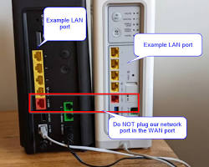
ANS :-

Cable Type :
Cat6 Ethernet Cable with a clear plastic RJ-45 connector.

What it Connects :
The cable plugs into the WAN/LAN port on the back of a home Wi-Fi router. It connects the router either to a broadband modem or directly to a wall ethernet jack, bringing high-speed internet into the router so it can broadcast Wi-Fi to smartphones, laptops, and smart TVs.

